Graphs from R

Box Plot of number of repositories

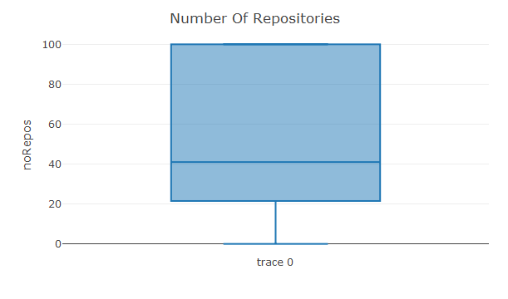

Scatterplot of 100 user’s data

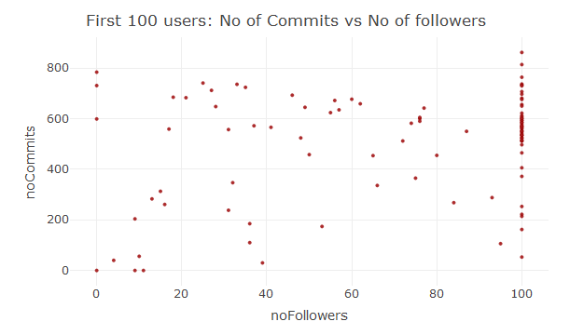

Scatterplot of Members of Organisation Data

